[**TopCoder Cockpit Direct UI Layout Part 2 Bugs Termination**](http://community.topcoder.com/tc?module=ProjectDetail&pj=30032089)

**Deployment Guide**

Revision History

|  |  |  |
| --- | --- | --- |
| **Author** | **Revision Number** | **Date** |
| TCSASSEMBLER | 1.1 | 01/29/2013 |
|  |  |  |
|  |  |  |
|  |  |  |

Deployment Instructions 3

1. Organization of Submission 3

2. Application Setup 3

2.1 Ant .Properties File 3

2.2 Build Scripts Setup 3

3. Database Setup 4

4. Deployment Instructions 4

4.1 Deploy Direct Application 4

5. Starting 4

6. Verification 4

6.1 Verification 5

7. Resource Contact List 27

# Deployment Instructions

This submission is based on the svn version 224608.

# Organization of Submission

The content of submission follows directory structure provided below:

***direct***

Contains the sources for TopCoder Direct application added/updated in the course of this assembly. This directory replicates the application development distribution structure and includes only updated and new files.

***docs***

Contains this document, which is the Deployment Guide for the TopCoder Cockpit Direct UI Layout Part 2 Bugs Termination assembly.

***database***

There is one sql statement wrong in VM, the correct version from TopCoder Project Manager is kept here and it needs to be updated to VM environment.

***test_files***

N/A.

This assembly uses the TopCoder test module to generate the test data, the module is available at <http://apps.topcoder.com/wiki/display/docs/TopCoder+Systems+Test+Data+Loader>.

***web_module***

N/A

# Application Setup

The application is expected to be deployed to the following environment:

**TopCoder Direct application**

JRE 1.5

JBoss 4.2.3.GA

Informix DS 11.0

## Ant .Properties File

N/A

## Build Scripts Setup

The build script for TopCoder Direct application (build.xml) provides the following targets which are to be used:

* deploy – builds and deploys the TopCoder Direct application to target server.
* deploy-apache-static – copies static web resources to .Apache HTTP server

This assembly uses the existing TopCoder Direct application build scripts, no update is required.

# Database Setup

Follow the steps below to update the database query:

1. Add the following entry in your host file:

<your vm ip> tc.cloud.topcoder.com;

1. Follow the link:  
    tc.cloud.topcoder.com/query/query?t=DBSelection&db=java:TCS_DW;
2. select db TCS Data Warehouse;
3. find query dashboard_participation_stats_aggregation_contest;
4. update the query content with attached

# Deployment Instructions

This section provides the instructions for integrating and deploying the changes from TopCoder Cockpit Direct UI Layout Part 2 Bugs Termination assembly.

## Deploy Direct Application

* Login VM as direct.
* Stop the current JBoss instance.

jbb

./kill.sh

(Then input “y”)

* Delete JBoss cache.

rm -rf ~/jboss-4.2.3.GA/server/default/work/jboss.web/localhost/direct

* Upload files under direct directory from my submission to /home/direct/direct in VM.
* Build and deploy TopCoder Direct application using ant deploy command.

cd ~/direct

ant deploy

ant deploy-apache-static

# Starting

* Build and deploy the TopCoder Direct application.
* Start JBoss server instance hosting TopCoder Direct application. Login in VM as direct:

jbb

./start.sh

tn

# Verification

Before testing, please load test data into the VM database following TopCoder System Test Data Generator Deployment Guide.

Add “cockpit.cloud.topcoder.com” to your hosts file to point to your VM.

## Verification

### Open <https://cockpit.cloud.topcoder.com/direct/>, login as heffan/password.

### Follow the instructions from the layout issue tickets’ link, and do the verification.

#### COCKPITUI-102

Steps   
-----------------------------------------------------------------

1. Go to Login Page, <https://cockpit.cloud.topcoder.com/direct>
2. Login as heffan
3. go to Overview Page
4. go to Settings Tab
5. Select the option "Permission" from the "Select a Setting Panel" drop down list
6. go to Users Option
7. check the table

Expected result   
-----------------------------------------------------------------   
The Expand/Collapse buttons and the check boxes must aligned each other   
  
  
Actual result   
-----------------------------------------------------------------   
As expected

Browser: IE9

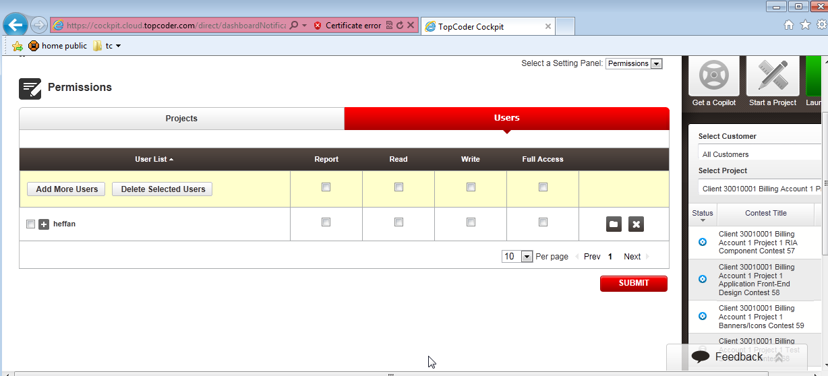

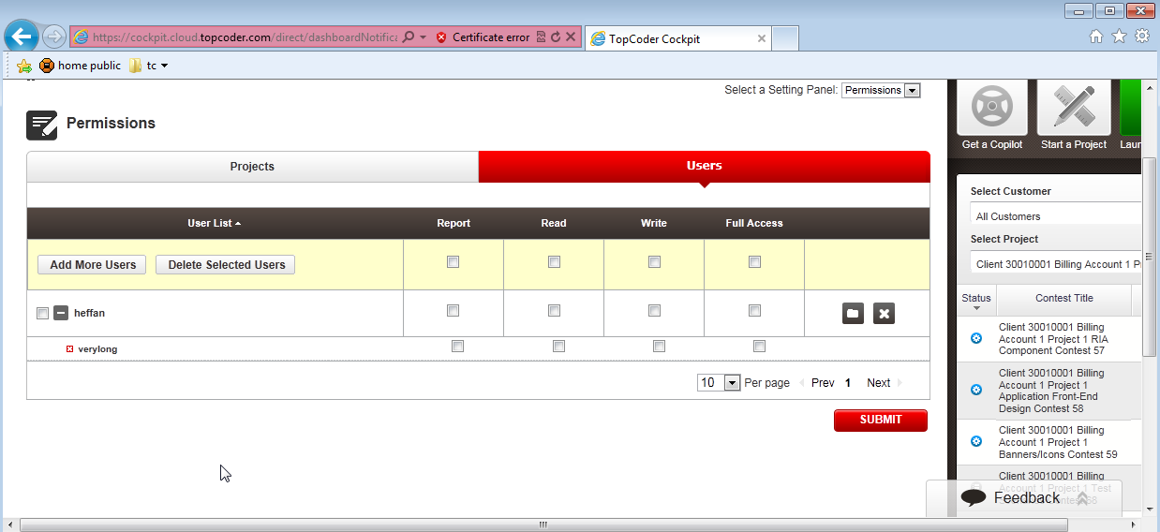

#### COCKPITUI-110

Steps   
-----------------------------------------------------------------

1. Go to Login Page, <https://cockpit.cloud.topcoder.com/direct>
2. Login as heffan
3. go to Copilot > manage Copilot
4. in the project view, expand a project
5. then delete a copilot from the list
6. check the confirmation dialog box

Browser: IE9

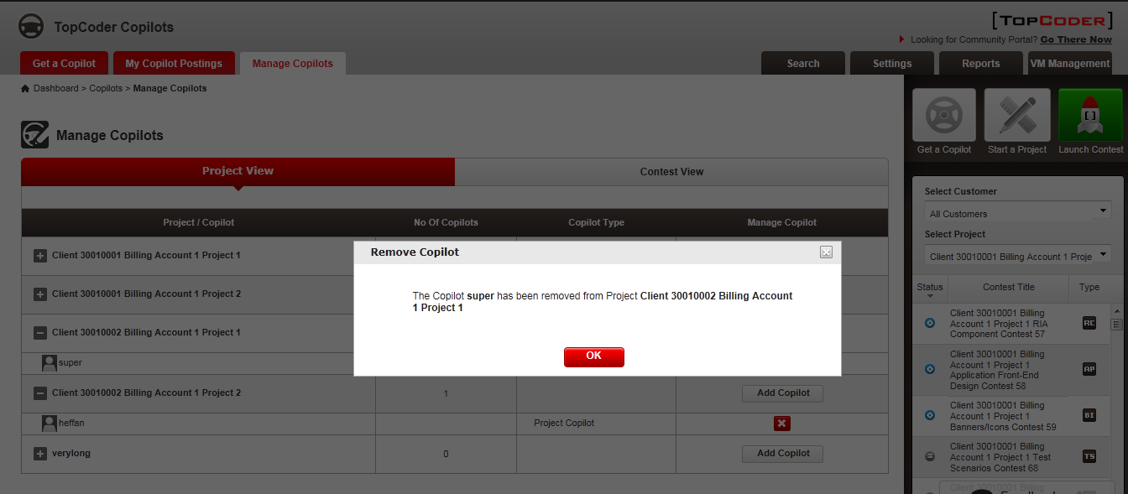

#### COCKPITUI-115

Check the layout is aligned vertically.

Browser: Firefox

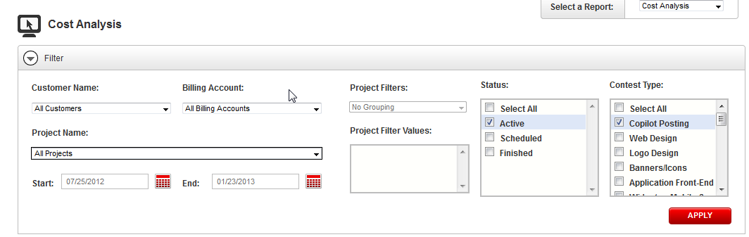

#### COCKPITUI-119

Check the ‘SAVE PREFERENCES” buttons are aligned properly.

Browser: IE9

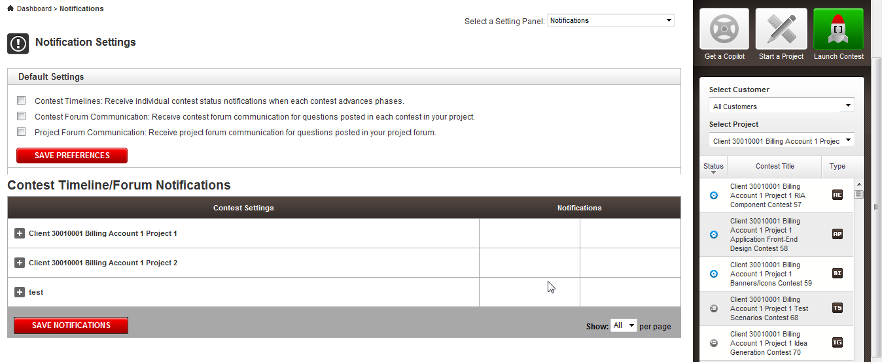

#### COCKPITUI-122

Check that the scrollbar is gone.

Browser: Firefox

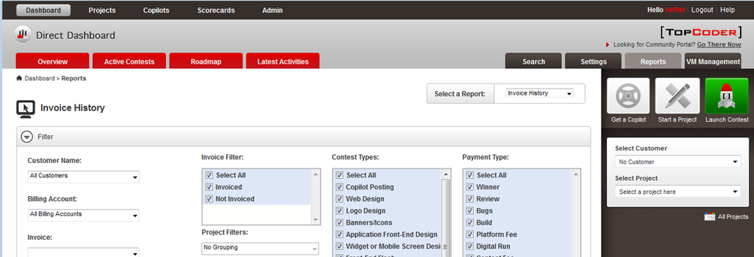

Browser: IE9

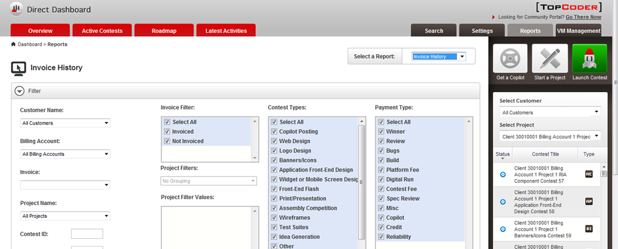

Browser: Chrome

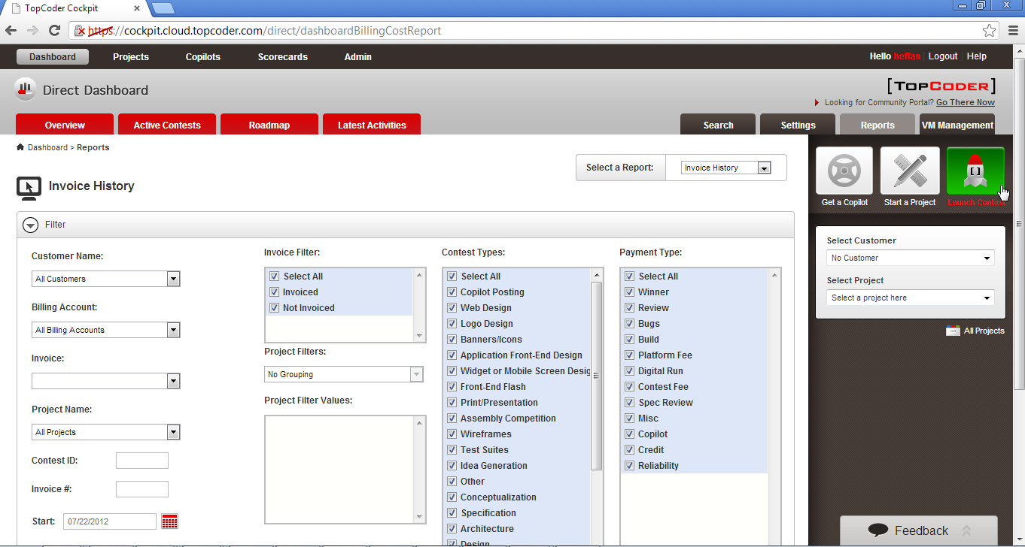

Browser: Safari

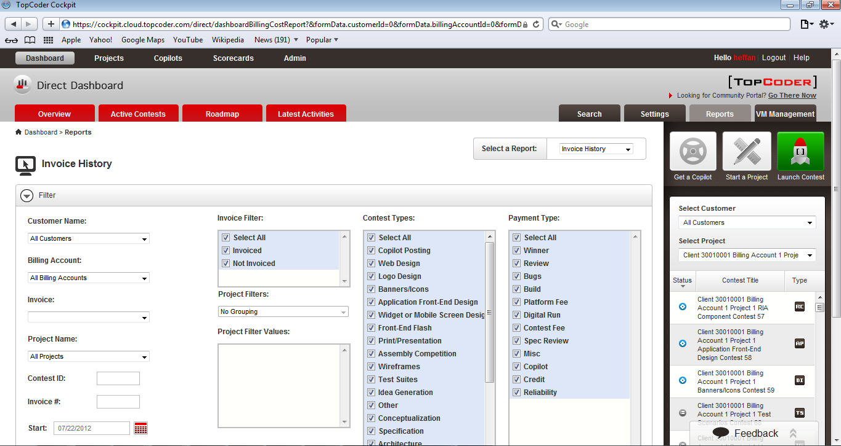

#### COCKPITUI-127

Check that we added border in the right side of "Status" and "Contest Type" box.

Browser Firefox

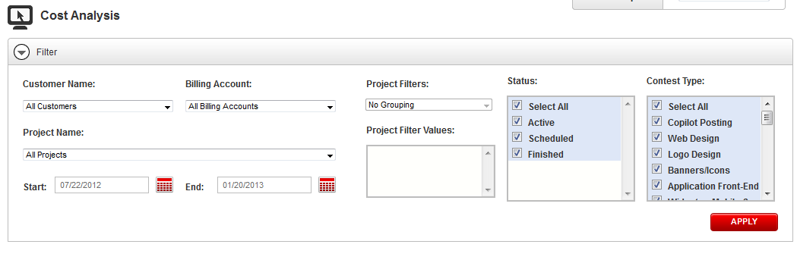

Browser: Chrome

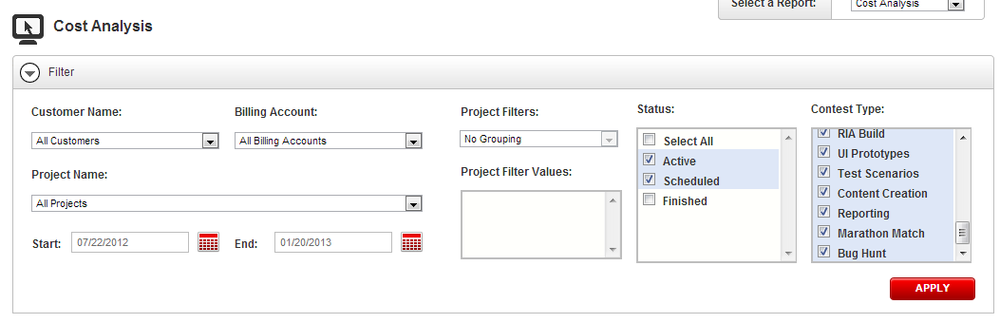

Browser: Safari

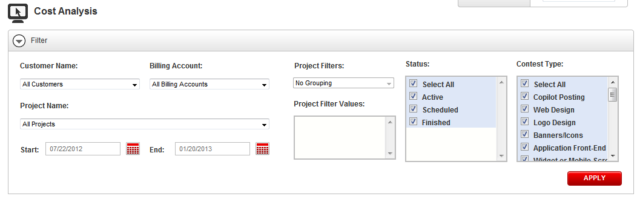

Browser: IE

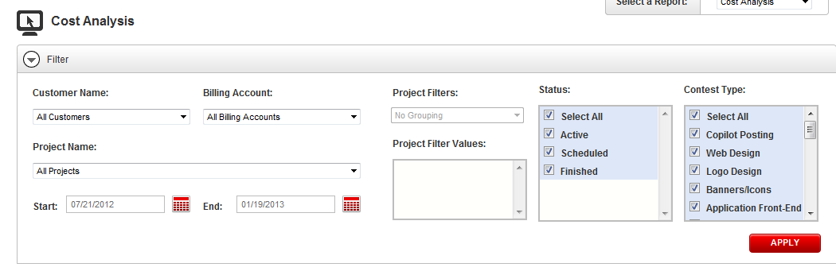

#### COCKPITUI-136

Check that "From" and "To" Field headings are changed to bold.

Browser: Firefox (similar for IE, Chrome, Safari).

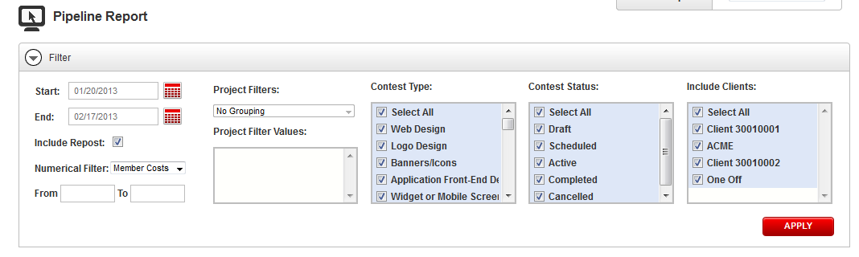

##### COCKPITUI-142

Check that last column of the Cost Breakdown View table where the background was missing is fixed.

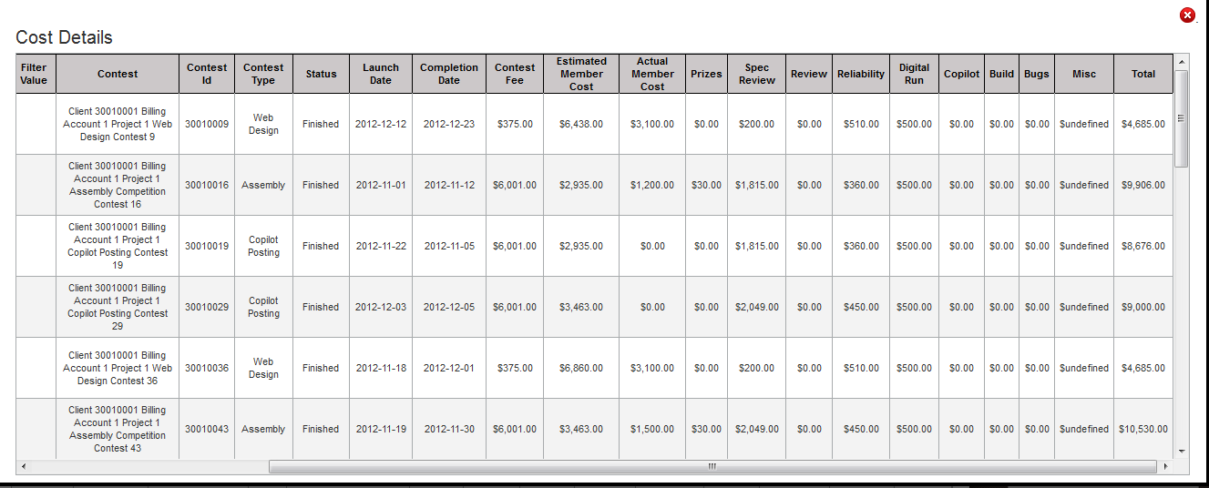

##### COCKPITUI-144

Safari

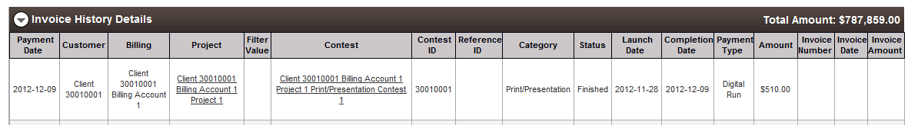

Chrome:

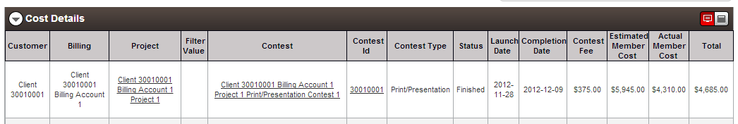

IE:

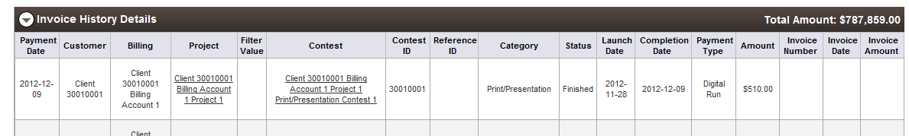

#### COCKPITUI-147

Check that no gap between the heading and the "Invoice History Details" table.

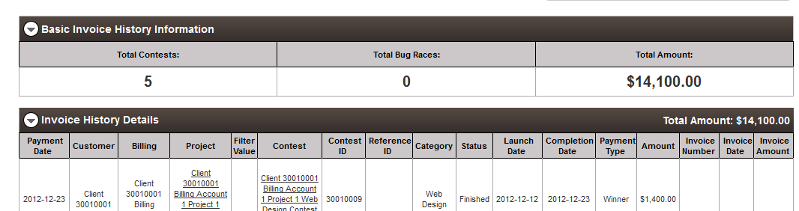

#### COCKPITUI-151

Check that the tables column headers do have separate border.

FF:

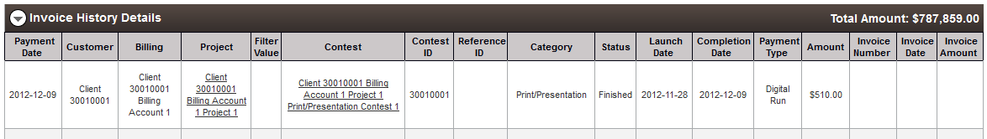

Chrome:



IE:  
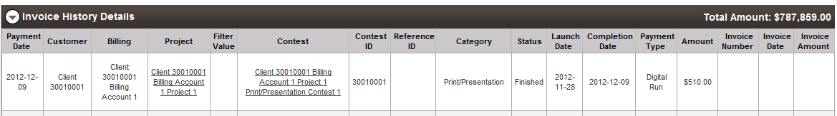

Safari:



#### COCKPITUI-153 - "Total Amounts" need vertically aligned

Steps   
-----------------------------------------------------------------

1. Go to Login Page, <https://cockpit.cloud.topcoder.com/direct>
2. Login as heffan
3. go to Overview Page
4. go to Reports Tab
5. in the "Invoice History" section - Select the Option from the "Select a Report" section
6. Apply a Filter
7. then go to "Invoice History Details" table
8. Check the Heading "Invoice History Details" and the Amount in the right side

Safari:



#### COCKPITUI-156

Cost Analysis:

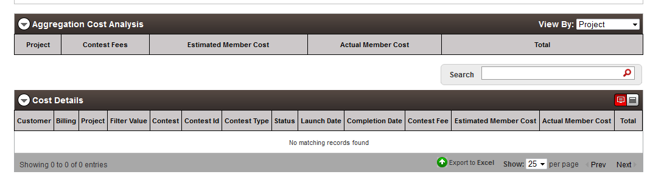

Participation Matrix:

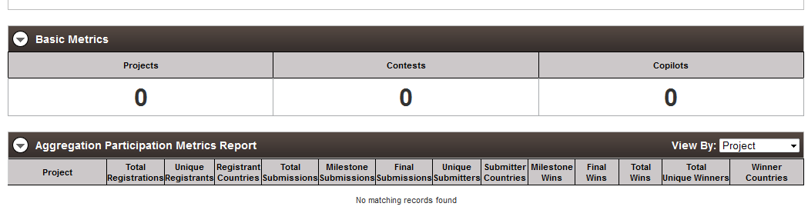

#### COCKPITUI-160

Steps   
-----------------------------------------------------------------

1. Go to Login Page, <https://cockpit.cloud.topcoder.com/direct>
2. Login as heffan
3. go to Overview Page
4. go to Reports Tab
5. in the "Participation Metrics" section - Select the Option from the "Select a Report" section
6. Apply a Filter
7. check the "Aggregation Participation Metrics Report" Table header

Safari:

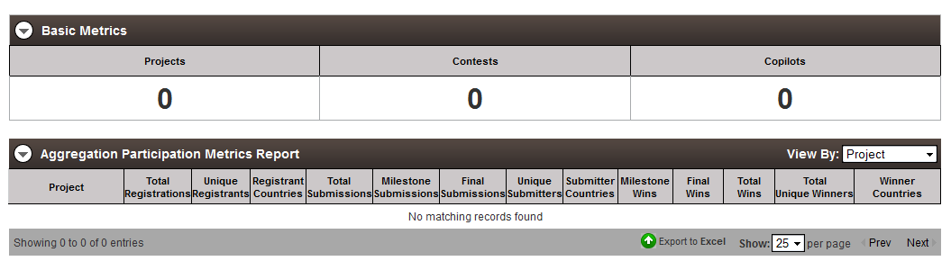

#### COCKPITUI-163

Steps   
-----------------------------------------------------------------

1. Go to Login Page, <https://cockpit.cloud.topcoder.com/direct>
2. Login as heffan
3. go to Overview Page
4. go to Reports Tab
5. in the "Project Metrics" section - Select the Option from the "Select a Report" section
6. Apply a Filter
7. check the Status Section alignment

Chrome:

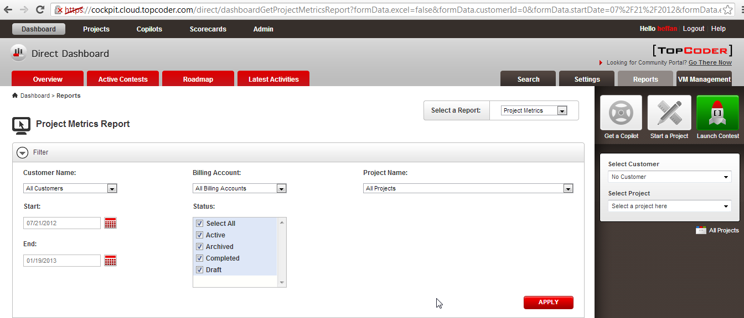

Firefox:

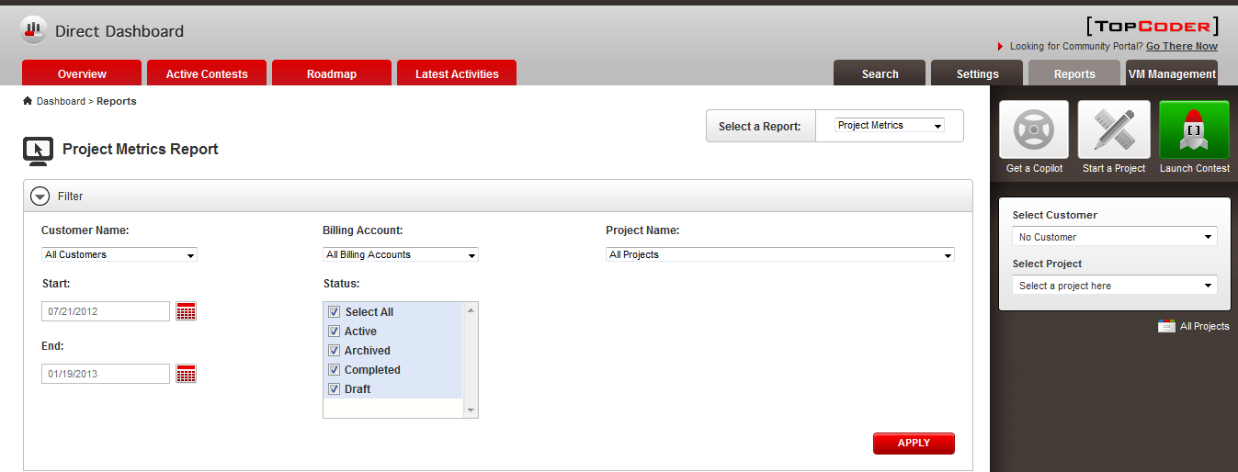

IE:

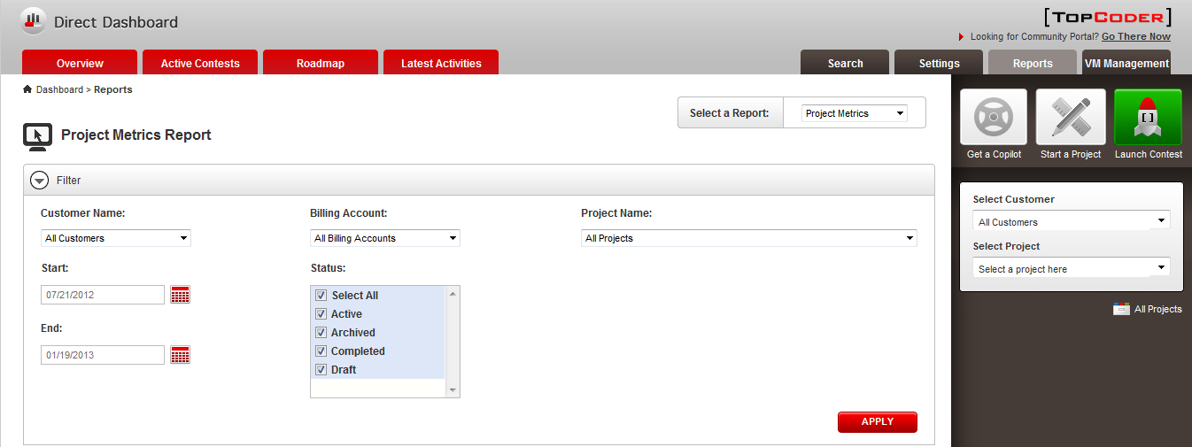

Safari:

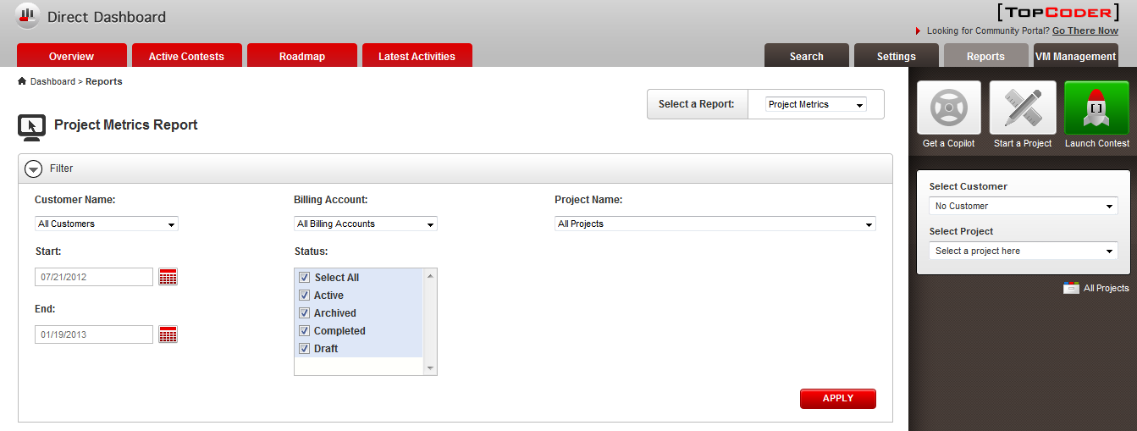

#### COCKPITUI-180

Check that the search page layout issue is fixed.

IE:

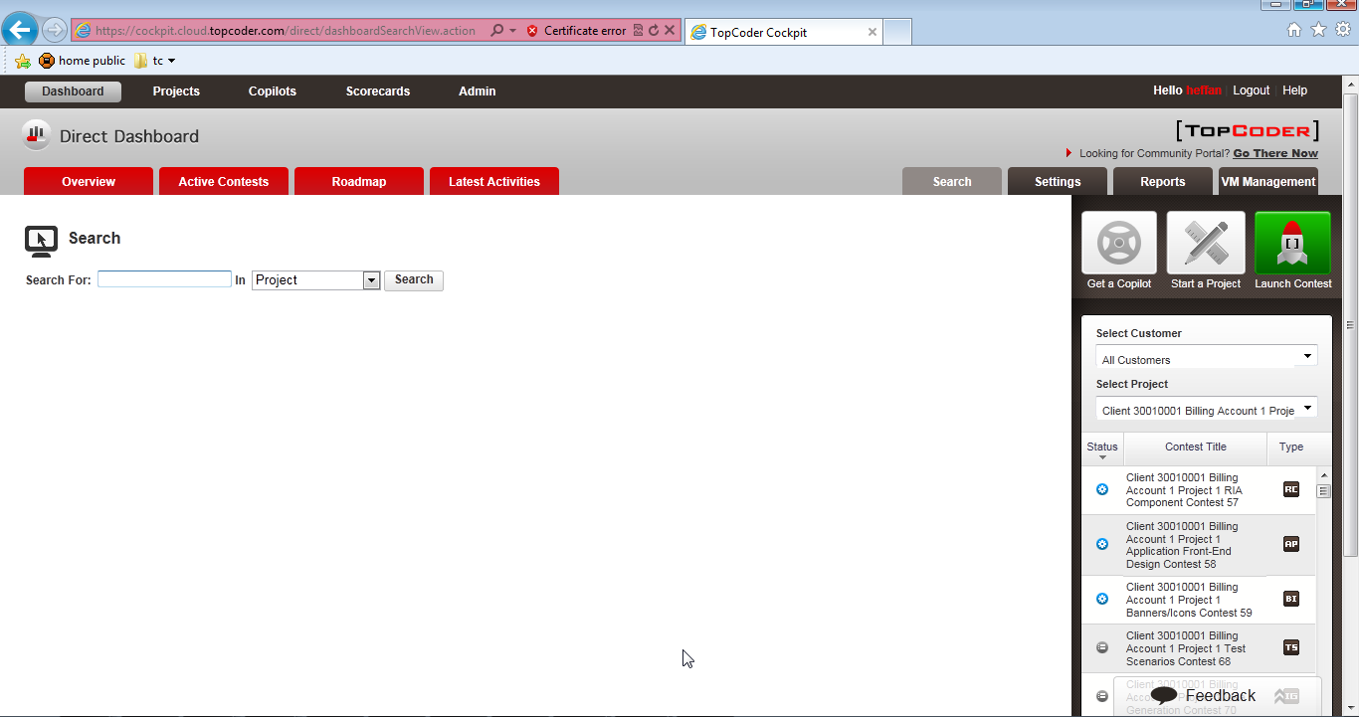

FF:

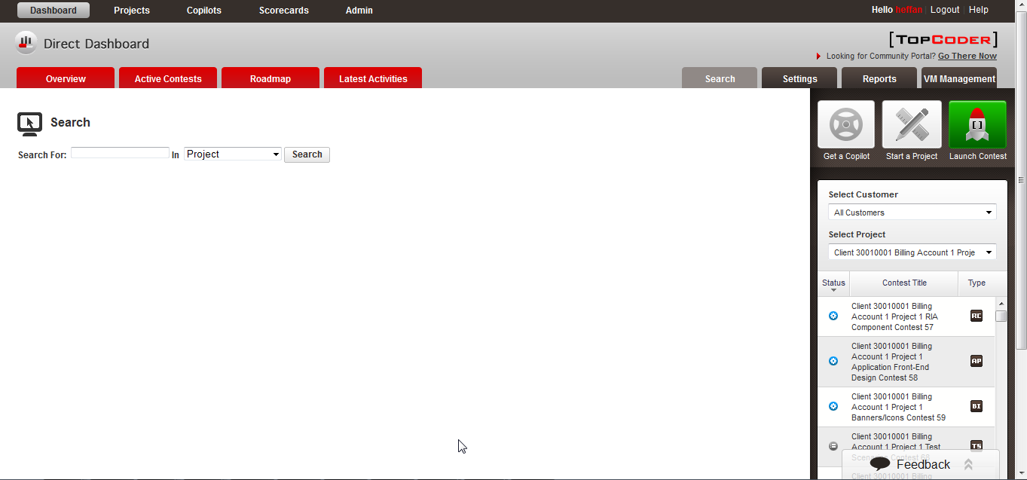

Similar for Safari and Chrome.

#### COCKPITUI-187

Steps   
-----------------------------------------------------------------

1. Go to <https://cockpit.cloud.topcoder.com/direct/dashboardNotifications>
2. heffan/password
3. Select a Setting Panel: as "Permissions"
4. Choose Users
5. add new user
6. remove user button "x" is shown

Expected: Hand cursor

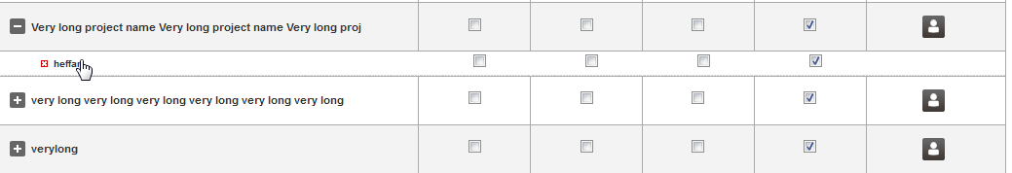

#### COCKPITUI-193

Check that bottom Border of the last record that was missing in the table "Enterprise Health" is added.

Safari:

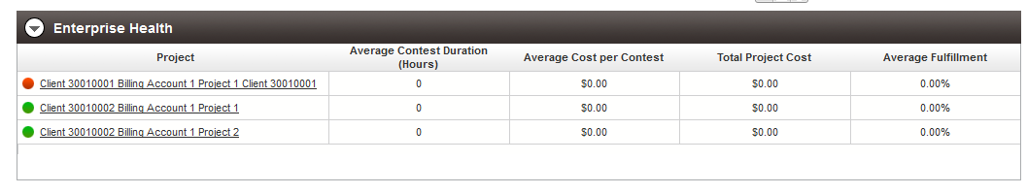

#### COCKPITUI-194

Check that cursor when mouse placed above "Select a Report" text is removed.

FF:

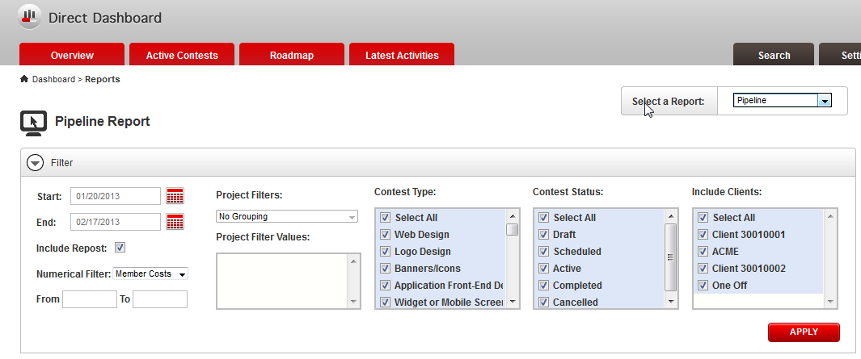

#### COCKPITUI-195

Check that Fixed "Start" and "End" date are bold now.

FF:

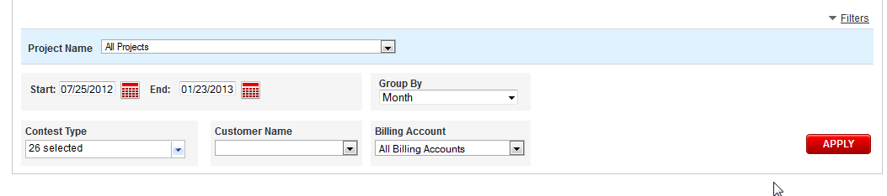

#### COCKPITUI-197

Steps:

1. Go to Login Page, <https://cockpit.cloud.topcoder.com/direct>
2. Login as heffan
3. go to Dashboard > Cockpit Dashboard
4. Go to Chart View
5. Click on the Filter link

Check that "Group By" section and "Billing Account" sections are aligned.

FF:

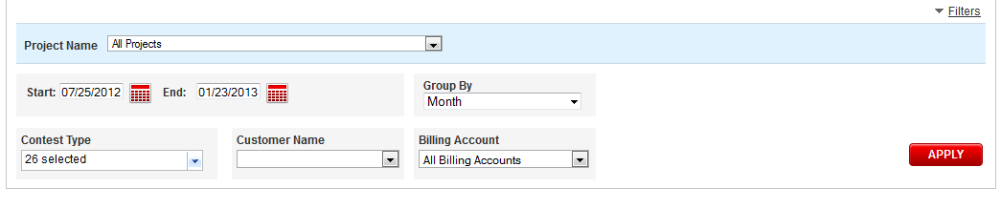

#### COCKPITUI-198

Steps   
-----------------------------------------------------------------

1. Go to Login Page, <https://cockpit.cloud.topcoder.com/direct>
2. Login as heffan
3. go to Copilot > manage copilot
4. click on the Project view
5. click on the "Add copilot"
6. check the Model

Check the buttons are in upper case.

FF:

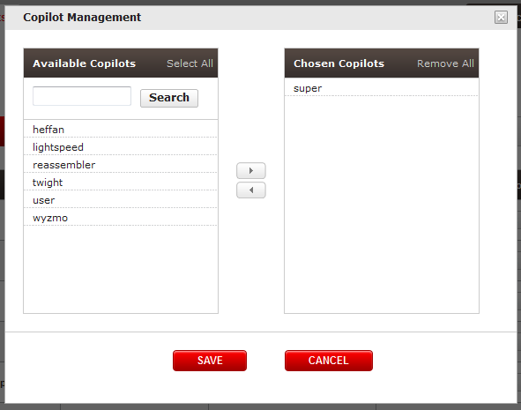

#### COCKPITUI-201

Steps   
-----------------------------------------------------------------

1. Go to Login Page, <https://cockpit.cloud.topcoder.com/direct>
2. Login as heffan
3. go to Dashboard
4. check the right side section "Select Customer" and the two drop down boxes

FF:

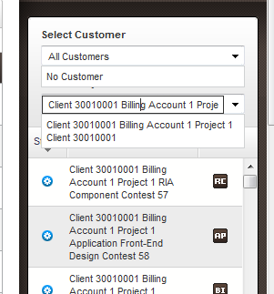

#### COCKPITUI-213

1. Click <https://cockpit.cloud.topcoder.com/direct/launch/home>
2. heffan/password
3. In launch new contest page populate required data(choose contest type as software conceptualization, Round Type as multi-rounds) and click continue
4. In the drop down menu near to "for each submission up to" if you hover over the white space (near 1,2,3,4,5) hand cursor is shown
5. Clicking there has no action
6. Expected: Hand cursor should be shown only when we place the cursor on 1,2,3,4,5.
7. Actual: as expected.

FF:

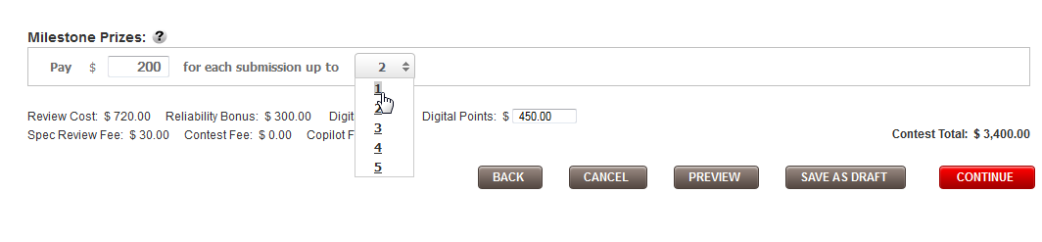 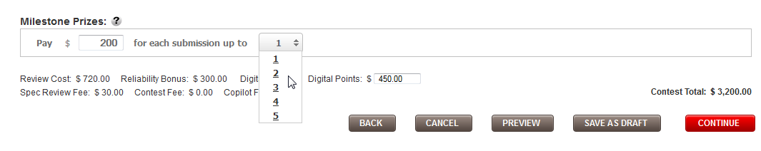

The same has been applied for project name in ‘launch new contest’ page.

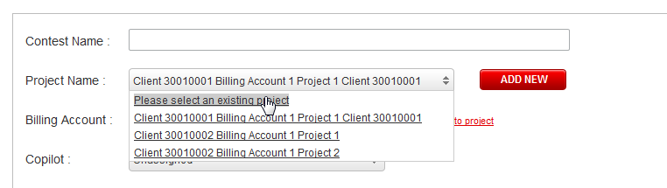

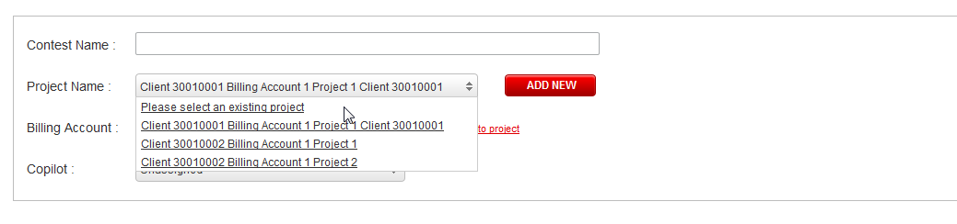

#### COCKPITUI-231

Check the font size is the same in the sentence.

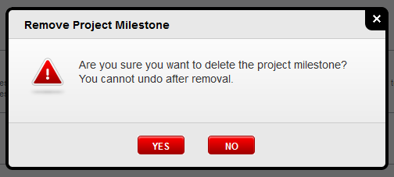

#### COCKPITUI-235

Steps   
-----------------------------------------------------------------

1. open [https:// cockpit.cloud.topcoder.com/direct/](https://23.23.49.7/direct/) , login
2. click Project Milestones
3. check a milestone

IE:

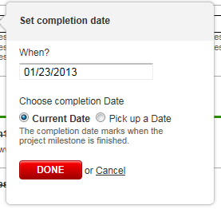

#### COCKPITUI-236

Check that the error message is placed below the input

IE:

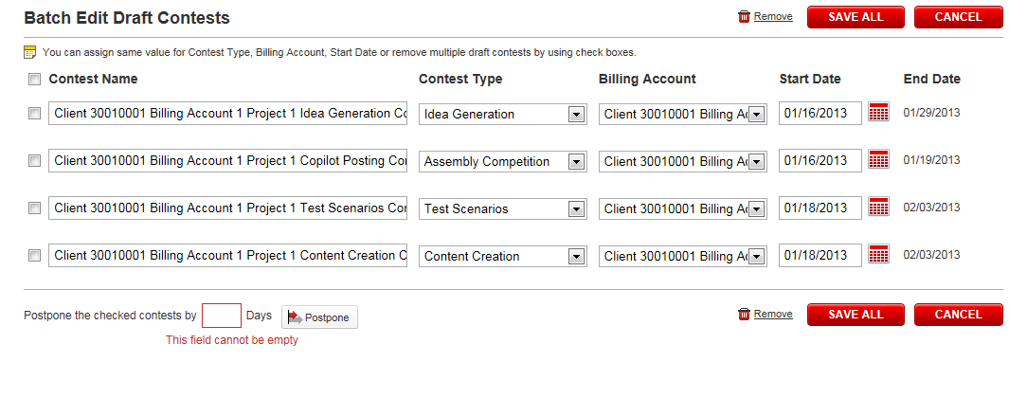

#### COCKPITUI-249

Steps   
-----------------------------------------------------------------

1. Go to <https://cockpit.cloud.topcoder.com/direct/launch/home>
2. Logged as heffan -> click 'Launch Contest'
3. In 'Project Name' drop down, select the lengthy named project
4. Expected: Selected option should not display out of the drop down box.
5. Actual: as expected

FF:

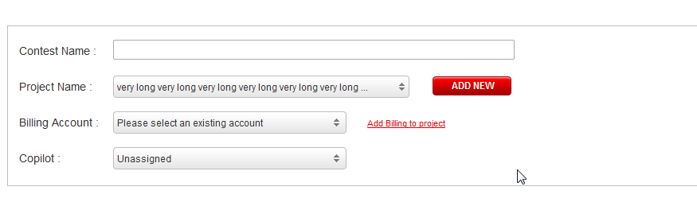

#### COCKPITUI-262

Check that the description is properly wrapped.

Safari:

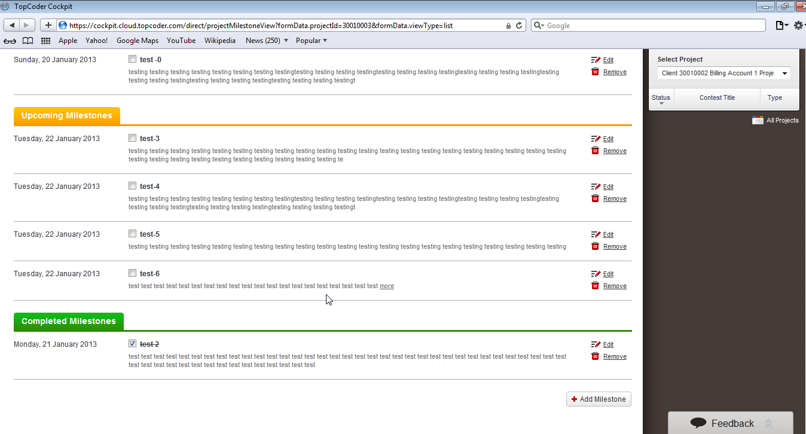

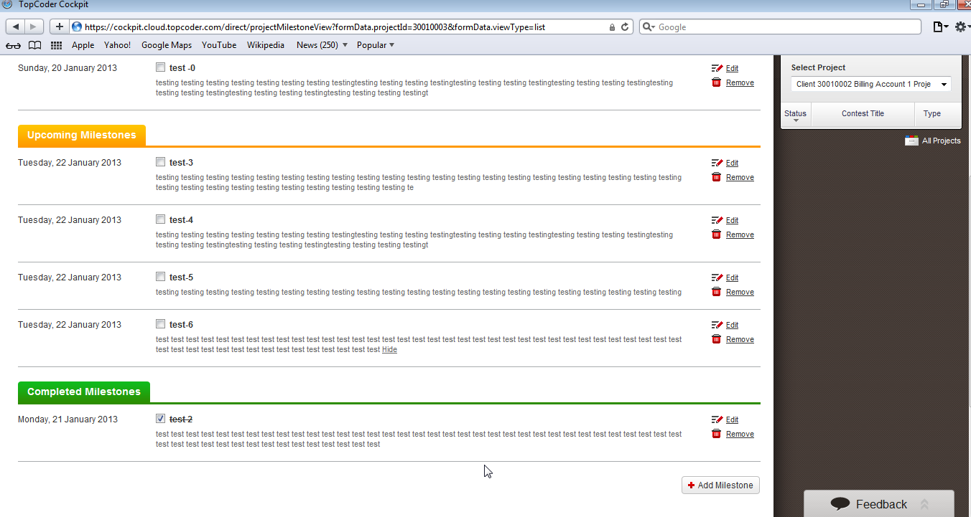

The result is the similar in FF

#### COCKPITUI-263

Check that the networking Icons on the Footer is not Overlaps by the Feedback Form in Start a New Project.

FF:

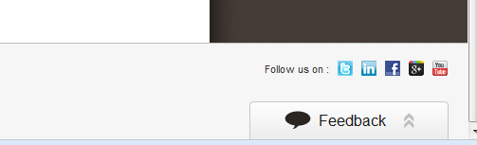

#### COCKPITUI-270

Check that there is no missing background load for custom image.

Safari:

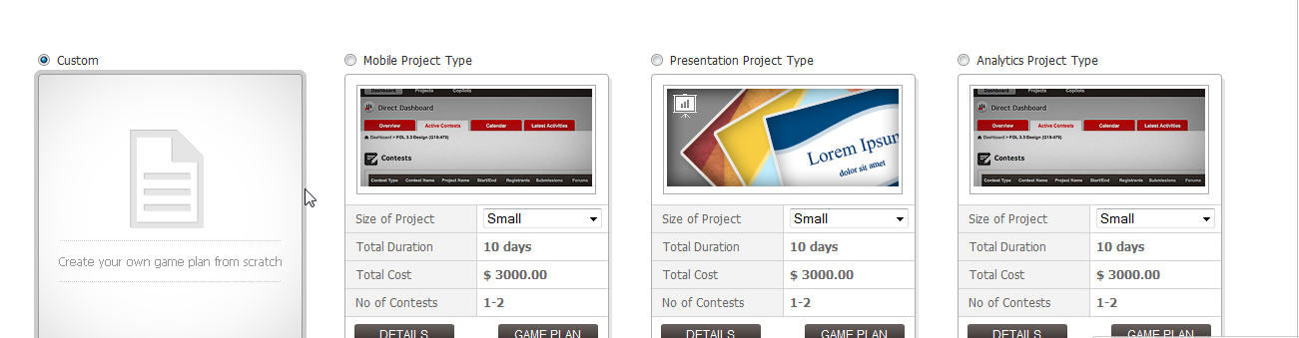

#### COCKPITUI-275

Check that "*" (asterisk) character is added to Title and Summary.

FF:

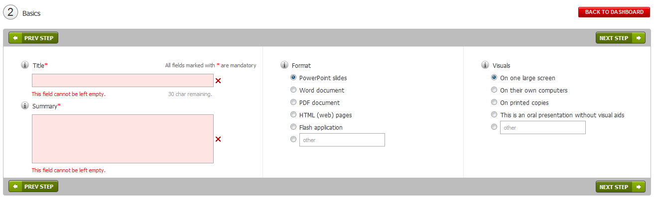

#### COCKPITUI-292

Steps   
-----------------------------------------------------------------

1. Go to Login Page "<https://cockpit.cloud.topcoder.com/direct/>"
2. Login as heffan
3. In the Dashboard, click on a project name
4. Then go to the "Project Milestone" Tab
5. Click on the "Add Milestone" button
6. After pop up appears, check the bottom of the page (footer area)
7. When the Model is Active user can click on the Feedback Pop up
8. Check the screen shot, the ‘feedback’ link is not clickable.

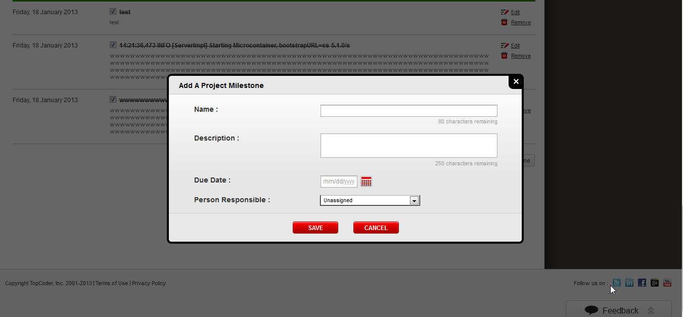

#### COCKPITUI-294

Check that the visual options are in one line.

Chrome (Similar for other browsers):

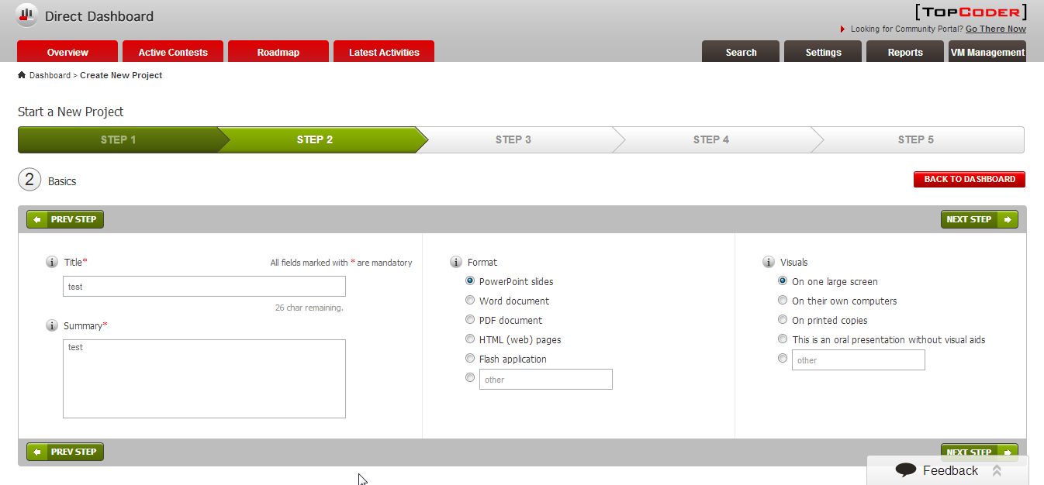

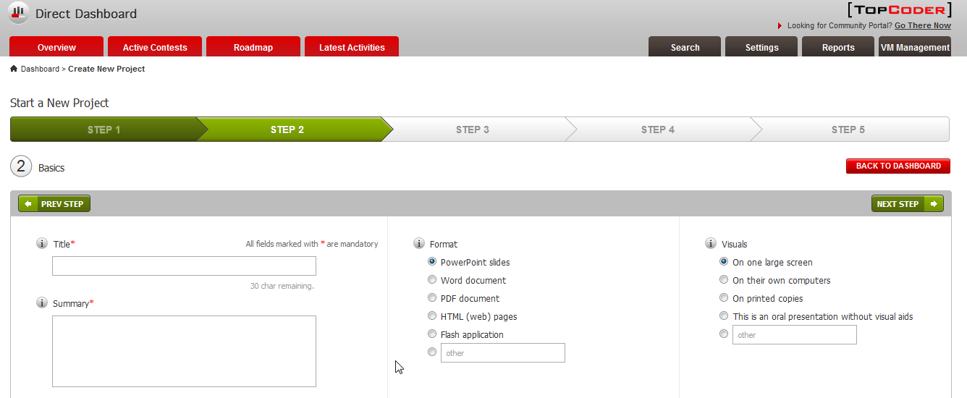

# Resource Contact List

|  |  |
| --- | --- |
| **Name** | **Resource Email** |
| TCSASSEMBLER |  |